Integrative Case Study

Andrea Jean Andell P. Salem

December 16, 2012

______

EDUC 613:
George Mason University

Part I. Descriptive Discussion

Introduction

Students are capable of learning and expanding their knowledge base when they are given meaningful opportunities, activities, and task. They learn from social experiences that are innate in any classroom across the globe. Students who belong in a classroom where the teacher is proactively tailoring the instruction to each individual, as well as for small and whole group teaching, are in a better position to develop all domains of learning and achieve a better sense of themselves as learners.

In this case study, I will discuss Kareem (pseudonym) who is a fourth grader student. Kareem is very self-conscious and sensitive nine year old boy, who is currently frustrated with learning and has constantly communicated his frustration both in terms of behavior and language. Having taught his other siblings, I am intrigued by his response to learning in my classroom and the apparent display of unwanted behavior that his other siblings never showed me. With this study, I seek to find out why his academic ability and over all behavior a direct mismatch to what his teacher from 3rd grade and his mother shared with me. Is this a simple frustration with the materials and learning expectations inherent in the 4th grade curriculum, or is it a matter of lack of background knowledge that can provide the scaffold he needs to make his learning more meaningful and interesting as he tackles our curriculum? Also, I want to find out if he is affected by the level of achievement demonstrated by his siblings and how it affects his self-efficacy as a learner both in the school and at home. This case study will be divided in to three major components: a descriptive discussion, an analytic discussion, and a reflective self evaluation.

Physical Description
Kareem is a nine year old Afghanistan-American male. He is short for his age, has black hair and black eyes. He speaks, understands, and writes Arabic with fluency and comprehension. He speaks, understands, and writes English proficiently. He likes playing soccer and is a member of a local league. He is more of a follower in his class and is generally shy. He loves making comic strips however he tends to lean towards violent ideas (guns, killing, blasting buildings). He is prone to broken bone injuries and wears his cast and bandages like regular clothing.

He easily gets irritated by other kids and when things do not go according to his expectations. He communicates this irritation through actions and use of offensive language. In the beginning of the school year, he kept on talking about his height and how short he is compared to his sister and to his friends and classmates. He is very conscious of the fact that he inherited this from his mother base on his observation of relatives from his mother side.

I chose Kareem because I would like to find out how his view of himself as a learner and as an individual affects his schooling. He is in his pre-adolescent stage in his growth and development which is a very sensitive and can be critical period in any child’s life. I would like to ensure that he will get the necessary support that will put him in a better position to succeed academically, mature personally, and grow positively towards learning.

Background
Kareem is the middle born child in his family. His parents are both second generation Afghani Americans who came from well-educated backgrounds. Both parents are computer engineers working from home. The family moved from Ohio to Maryland when Kareem was five years old. He has an older sister, who was in my 4th grade class last year, and a younger brother who is in my 3rd grade class this year. All three siblings went to our school in 2008 but continued their schooling in the public school from 2009-2011. They all came back for school year 2011-2012. This school year, the older sister went back to public school while the two boys were re-enrolled to our school. The mother has expressed that she will not deny any of her children the opportunity for public school learning if they so wish to go there. Both Kareem and his brother chose to attend our school for personal reasons. While in the public school and all the way until last school year, all siblings were attending Kumon after school program for math and reading. This school year, none of them are attending the program.

Kareem is a practicing Muslim who is consciously aware of his identity and the teaching of Islam. As his non-Muslim teacher, he is aware of their tradition that I don’t practice and will offer explanation of the whys and what of the Muslim world.

From the informal interview of his 3rd grade teacher (Appendix B), Kareem was described as a reluctant reader with high ability in math. It was also noted that he disliked doing his homework. His mother has confirmed that he dislikes homework and that he didn’t do any homework last year. His interest is mainly soccer and drawing. He will be more inclined to write when the drawing is integrated to the task. He is particularly drawn to comic strip writing/drawing. In learning, he prefers to sit by himself and work alone. He participates in group work in terms of doing application of learning work, but prefers sitting by his desk when receiving direct instruction.

His Lexile Level score from last year’s Stanford 10 Standardized Test was 510L (Appendix A). He meets the county level set at 500L but is in the lower end in comparison with his peers. The result of his Stanford 10 Standardized Test in reading places him in the 38th percentile with a Stanine score of 4 which falls in the lower end of the average bell curve. His math shows that he is in the 52nd percentile and Stanine 5 which classify him as average learner. In all aspect of the Stanford 10, he is categorized as average learner in the norm-referenced test. His below average areas from the cluster reporting indicates that he needs help with reading vocabulary and reading comprehension. As for math, he needs attention in the areas of mathematics procedures.

Much of his sharing involves his experience with the public school. He constantly refers back to his days being bullied at the public school he attended and continues to express that attending our school is the best thing that ever happened to him. He is very sensitive to his surroundings and always participates in non-class conversations. At some point, he expressed that social dialogue is more rewarding than having to play games during recess.

Very recently, Kareem was using the term “depressed” to describe his life and expressing thoughts that are not appropriate for his age. He accounts it to the recent events in his life: the untimely death of his young uncle and the broken engagement of his cousin of which he was suppose to be part of the wedding entourage. He was also shaken by his initial misconception of one of the Muslim teachers at school which he thought had a tattoo on her wrist. He explained that this is upsetting to him because he knows for a fact that the teacher was a “true Muslim”.

Setting
Kareem attends Mali Preparatory located in Rockville, Maryland. The school’s student population is predominantly Muslim-base coming from diverse countries. Majority of the students have ties with the diplomatic community and attend our school as an alternative to public school education. The school is a private school serving preK-12 students in the Virginia-DC-Maryland area. According to the National Center for Education Statistics, 88% of our students are classified as “White, non-Hispanic”, while 6% are Black, non-Hispanic. We are a tax-exempted non-profit school. Majority of our students come from middle-class families with both parents working in professions requiring Ph.Ds.

Kareem is one of my 4th grade students who I teach in the areas of Language Arts, Math, Science, and Social Studies. I have 15 students in total: 6 boys and 9 girls. They are all bilingual but are not considered ESOL. One student classified as needing SPED. The classroom setting includes two large group of tables set face-to-face—one column for girls, and the other for boys, in accordance to the Islamic practice of these students who are of age (girls are to be separated from boys specially when they reach the age of 9 years old). I have a U-table at the left side of the room for small group instruction. This setting allows grouping and cross-gender grouping whenever needed. Small-group instruction is not common-place in our traditional school practice which entails that this will be the first time that these students will experience small-group instruction as part of my 4th grade classroom and teaching practice.

Our classroom is in the 2nd floor of our school’s building. The upper right quadrant of my classroom houses the teacher’s table, the U-table sits on the upper left quadrant of the class. The classroom has two whiteboards, a retractable screen for use with the LED projector. Three 7ft x 5ft bulletin boards hang on the other walls of my classroom. There are two windows that overlook the residential area of where our school is nestled.

Learning Factors
The Learning Factors I will concentrate on this case study are: Personal/Social Factors, Developmental, and Affective Learning Factors. Since I was able to teach both his sister and brother, it will be interesting to find out how Kareem interacts with his siblings in the home environment and his peers in the school learning environment. Having the opportunity to work with him in my classroom, I would like to find out if the social interactions in my 4th grade class support his learning and if he is able to find avenues to empower himself as a learner who are co-creators of their own learning experiences. It would also be helpful to find out how much influence his parents have on his learning and how his ordinal birth position affects his overall personality. For the developmental factor, I would like to find out if there are areas in my planning and instruction where I can better help Kareem to meet his developmental needs. After a month of working with him, I am noticing that he’s always having a hard time understanding math concepts. I have seen him work on math procedural problems and he seems on top of math functions involving computations, but not concepts that involve vocabulary and math properties. I want to explore other ways and models of teaching that will reach out to his learning style and learning ability. Also, it will be interesting to know how he relates his strengths and abilities to that of his classmates and how this affects his self-esteem and outlook of learning which will give me a better sense of how my classroom is supporting his affective domain.

Kareem’s expressed frustration with learning makes me interested to find out if he was placed above his ability last year. I want to know how to better help Kareem meet the learning expectations for 4th grade and move him along his learning continuum without further stress and frustration. To this end, I would like to find out what motivates him and why—an affective learning factor that I want to explore in this study—and work on creating a more stress-free learning environment, one that respects his ability and builds on it.

Summary
Student learning and engagement increases when the learning condition and environment are well supported by teachers. When students create bonds with their peers, the social process that is a crucial in learning is being met. These social experiences can change the brain in positive ways (Jensen, 2005). Having a sense of acceptance, approval, and recognition from friends, classmates, family members, and teachers have a profound effect in children. Kareem is at a stage right now where he is intentionally isolating himself from classmates and this has consequences and implications in his learning. His frustration with and in learning can be significantly reduced if I could pinpoint the areas that I can change to guarantee him better learning experiences and a stronger sense of himself as an individual with unique ability and talents. This case study hopes to find answers to questions that can help me as Kareem’s teacher meet his needs as a learner and as a maturing boy moving towards adolescence.

Data Source
Questions | Data Source | Learning Factors
Behavior issues | Parent interview, 3rd grade teacher interview, Parent Survey, Injury log, Informal Observation Log | Affective, Personal/Social
Motivation factors | Parent interview, 3rd grade teacher interview, Parent Survey | Affective
Self-efficacy | Reading and Writing Survey | Developmental, Personal/Social, Affective
Learning issues | DRA 2, Stanford 10 Result, ELA Progress Monitoring, Math Progress Monitoring, Report Card, Group Work/Tasks, Ticket Out, BCR Chart (ELA), Student Work | Developmental
Learning style | MI Survey | Affective

Part II. Analytical Discussion

Introduction

At the beginning of the school year, Kareem showed relative excitement and enthusiasm with schooling. However, as the weeks rolled in, I have noticed that he is slowly losing interest and was beginning to use language that reflects loss of self-efficacy and confidence. He started to detach himself from schoolmates and see himself relative to his peers. This highly affected his engagement and motivation for learning. Most of his 3rd grade friends moved to another school and with no 5th grade boys in the school, his choice of friendship was limited to a few younger students. Because of religious constraints and pickiness in choosing friends, Kareem is left with socializing with classmates who does not share the same interest that he has. All this compounded the growing issue of successfully integrating in his learning environment as he feels isolated and unsure of himself.

Kareem is at the stage of late childhood characterized by periods of heightened emotionality and wanting to belong in social groupings. Right now, he needs help with clearing his pent-up emotional energy. Although he is able to control his behavior, his moral attitudes needs guidance with his sensitive nature. The quality of relationships he has with family members, relatives, friends, and classmates is clearly evident in the way he speaks of them. His self-concept is shaken with the different events in his life.

From gathering background information from teachers, the parents and siblings, and from my own experience as Kareem’s teacher, it is apparent that this year is shaping up to be his challenging year. There are three key issues that I hope to address and find resolution with in order to help Kareem overcome his frustration with learning and schooling—Personal/Social, Developmental, and Affective Learning Factors. The lack of quality interactions he make with his peers and members of the learning community is really a source of concern this year. I hope to find out the reasons behind this barrier that he has created that prevent others from socializing with him unless it involves playing soccer. This personal/social factor is a big issue that affects his engagement in the class. Without the interactions that promotes exchange and ownership of learning, his self-efficacy is greatly affected. He fails to see himself as a contributor to the overall learning taking place in or outside the classroom. This affective learning factor has troubling effect on how he see himself that he now describe his attempts at any assessment as a “failure”. He then moves to isolating himself further. Ultimately, his development as a learner is likewise affected as he gets bogged down by the initial failure to engage himself and commit to the learning task that can build his knowledge and skills within the 4th grade curriculum. Knowing that student learning and engagement increases when the learning condition and environment are well supported by teachers, I intend to find ways to significantly reduced potential stress/s that affects Kareem at school.

Personal/Social Learning Factor
Hypothesis
According to Jensen (2005), the social experience is a brain-changing experience that can have either a positive or negative effect (p. 100). Learning is highly influenced by the social interactions and interpersonal relationships students form in school and at home. Creating positive interdependence enhances learning (p.96). On the other hand, social interactions can also bring about social stress when students are not able to integrate themselves into a group. With Kareem’s age, social support among males is critical as they seek to form their own identity. Insecurities can lead to psychological hazards identified by habitual withdrawal, chronic depression, and chronic anxiety—as manifested by Kareem. He needs to learn how to identify his feelings and where it’s coming from. My hypothesis is if he learns to channel his emotions to productive means such as journal writing, he will be able to move to a positive emotional state by recognizing that he has an emotional feeling that he needs to acknowledge and determine the source of. Removing him from his negative emotional state will increase the chances of him being engaged in the social interaction that is part of the learning process.

Way of Learning
With the limited choices of friends available for Kareem both at school and in his neighborhood, I understand where his struggle and frustration is stemming from. His inability to connect with others in a positive way negatively impacts his self-esteem as he does not have the support of friends who will rally behind him and co-highlight and affirm is potentials and talents. His frustration has impacted him academically as he is unable to move from this negative state to focus on the academic task while in class. He easily becomes agitated and would not cooperate in group works which affects others as well.

As mentioned earlier, Kareem is shying away from group work (Appendix C). During the first quarter, he displayed frustration with Math. In one of the video recording taken in class that used a small group instruction model, Kareem got frustrated since all the other four students in the small group got the concept. He was focused on what the others are doing and how they are progressing that he didn’t take any time to concentrate on his own learning. When the time was up for me to do the feedback loop, he latched on how he doesn’t know what to do and that everyone’s done but him. Ultimately, as the video recording captured, he tore his index card and crumpled it out of frustration. One way that helped me reach out to him in a more productive way is to do one-on-one teaching during their independent activity time instead of including him in a small group since he seem not ready for that type of instruction just yet. The one-on-one worked better for Kareem as he can focus on his own learning better without the interference of other students who might be progressing in a faster rate than he is. Eliminating the social stress to keep up with others put Kareem in a better position to be engaged in his own work and thus learn from the activity. Likewise, when I use common theme he used in his story writing for language arts, he is more likely to be engage in the learning process and take an active role in learning it independently once he gets the concept. Giving Kareem that initial support and verbal affirmation that he can learn the material provides the social persuasion that moves him to believe in his ability to learn the material. In another instruction segment that dealt with using graph to show the mode, median, and outlier of a given set of data, Kareem got frustrated once again and complained of not knowing what to do. This has become his M.O. (modus operandi), his escape mechanism. Knowing that he has a knack in drawing stories involving robbery and the like, I engaged him in a conversation that revisited his previous drawing done in language arts. From that initial story board, we came up with a graph showing the frequency of bank robbery in a New Jersey city (his cousins live in New Jersey). This enables him to connect the concept and take ownership of the learning as midway through the 1-on-1 instruction time, he told me he got it and that I can move on with someone else. He later showed me his work and explained where his mode is, the median and the outlier from his graph (Appendix D). Bandura support this when he said people who are told they can be successful are more likely to put in more effort (Akiyoshi, A., et al, 2012).

According to Vygostsky, social interactions influence cognitive development. As a teacher that Kareem opens up to, I am able to influence and help him develop the capacity to make positive decisions by teaching him emotional knowledge and emotional reasoning to understand his feelings and work his way out of the negative state. This is important because Kareem needs to successfully and positively overcome this psychosocial stage of his development to attain autonomy and build a positive sense of self (Child Development Institute, 1999).

Recommendations
Based on Kareem’s increased frustration and minimal success in student engagement, I recommend using the ability approach in teaching him emotional intelligence. Modeling how to positively process emotions may help him with managing his emotions and thereby lessening the stress factor associated with it thus helping him to concentrate to other tasks. Cobb and Mayer (2000) mentioned that correctly perceiving emotional information is one way children make sense of things (p. 56). Giving Kareem opportunities to write about the emotions he has can facilitate deeper understanding of these emotions and could be used as a “conversational anchors” as I teach emotional reasoning and how this impacts behaviors. This will likewise enable him to ponder and use his critical thinking skills as he evaluates his own emotions and its effect to his daily interactions and behavior at school. As Jensen (2005) stated, critical thinking skills take time to learn (p.116). Continued focus on using the ability approach using relevant experiences coupled by targeted activity will give the support he needs to understand his emotions and its effect to his daily interactions. The overall goal is for Kareem to understand that he can manage his own emotional state and when he learns to do this, he will be more likely to move from a frustrating state to a calmer state more conducive to learning. Kareem likes to write although he has mentioned that he doesn’t keep a journal. In this approach, I will have Kareem keep a journal at school where he can write his feeling/s for the day. The goal is for him to acknowledge the feeling through the writing process.

Another recommendation to provide him with a structured social skill instruction, one that eases him from 1-on-1, to a paired activity, to small group instruction until he is able to better manage his emotions. The loss of his close friends from third grade who were basically the ones he did group activity with during the last school year, had a negative effect on him. According to Billings et al. (1983), the loss or absence of a valued social companion is a robust risk for depression. Providing opportunities that foster camaraderie among his classmates, a sense of belongingness and teamwork through these structured activities can slowly help him build new happy relationships. Ability to have healthy and happy relationships with other students his age can lead to motivation and eagerness to achieve.

Recommendation on putting Kareem in extra-curricular/after-school sports was made during the Parent-Teacher Conference. His mother had informed me that he was part of a local soccer league but was not able to attend for a while because of his continued injuries (Appendix E). I have reiterated that given our school’s current pool of male students in the elementary group, it is better to seek other sources of social interactions aside from what the school can provide. The common interest in sport can create avenue for Kareem to form bonds and relationship where he is perceived as an integral part of the whole team. This can be very satisfying and gratifying to him to know that he belongs. Having a positive outlook is often time a result of doing something worthwhile that bring people a strong feeling of happiness. This is what Kareem needs instead of feeling so down, angry, and mad all the time.

Last, I recommend providing him with reading materials that depict students his age overcoming challenges that are common to his personal reality. This will exposed him to other sources of positive models of success with characters learning to managing conflicts and finding resolution to their problems. On top of that, these reading materials provide a moral lesson that Kareem can benefit from as well.

Developmental Learning Factor
Hypothesis
Kareem’s frustration with learning mathematical concepts and vocabulary words have lead me to believe that he might not have developed the thinking skills that enables him to see and understand abstract concepts. Jensen (2005) cites that brain matures in different rates which affect the capacity for both concrete information learning and abstraction (p. 118). Kareem’s performance in math and the frustration with learning the different mathematical concepts led me to believe that if he is given instruction that is centered on hands-on learning and use of visual concrete materials such as manipulative to learn abstract concepts, he will find more success in understanding math concepts and applying this learning to in problem solving. According to Piaget (2012), there is a developmental sequence that children follow as they grow and develop. Kareem is definitely showing that he needs help to move from pre-operational to concrete operational stage.

Ways of Learning
Kareem seem to benefit the most from one-on-one instruction using concrete objects and personally meaningful examples. When he is presented with ideas or problems from the workbook or textbook, he is unable to grasp the concepts needed and this causes frustration since his self-value and/or self-worth is automatically diminished from his perspective. He starts labeling himself as “dumb” and the “worst in the class” (Appendix F). For our math class, I do chapter pre-test and chapter test to track individual student’s learning. In the past four chapters, Kareem had gained an average of 50% gain from his pre-test scores. What I have noticed s that when he encounters problem that he is not familiar with, he spirals back to this frustration phase. He is able to transition when I talk to him one-on-one and give him assurance that chapter pre-test are not graded nor is it reflected in the RenWeb (our school’s online grade book system that students and parents can check), and are basically used to help me as their teacher know how to teach them better. This “conferencing”, mini talks work for Kareem because he sees that my attention is focused on him.

Also in math, when concepts are presented in such a way that he can relate to because it is significant to his life, or it is something that springs from his interest, he is able to understand the concept and/or process that he needs to learn. Jensen (2005) mentioned that learning is the result of the strengthening of the connections between two neurons (p. 128). As Kareem is able to connect the new learning to his interest and prior knowledge, he is able to retain the concept learned. He is able to encode it successfully which is evidenced by his ability to retrieve the information from the learning session that was more centered to his interest that sparked his engagement and motivation to learn the material. Differentiating the instruction for Kareem allows him to be more successful in learning new concepts and be more confident of what he can do. As he gains confidence, he is able to move towards ownership of the learning experience. Taboada, Guthrie, and McRae (2008) advocate this type of learning where student interest plays a pivotal role in the learning process. When students are given choices that are academically relevant and personally meaningful, students are more empowered and are at a better position to put forth the effort to learn.

Recommendations
As was mentioned, differentiated instruction that takes into account Kareem’s interest can potentially help Kareem build interest and motivation to learning mathematical concepts and skills. Providing choices for problem solving with more meaningful context can be a better option to gauge his understanding of math processes. Another recommendation is to plan activities that promote social interaction in the classroom to help Kareem build stronger relationships with others. As he gains more ownership in learning, giving him the opportunity to see others work and display their understanding can help boost his confidence and see learning as a social process. Social interactions that build upon student interchanges and allows them to build upon each other’s thinking is motivating for students. These social interactions can foster sense of belongingness, self-worth, and “relatedness” to others (Furrer & Skinner, 2003).

As individuals develop, there are different opportunities and constraints for learning (APA Learning Factors, 2012). In Kareem’s case, understanding math concept seems to take more time and practice to learn. I recommend providing Kareem instruction that uses visual and hands-on manipulative will help him understand concepts concretely. As Piaget mentioned, learners move from developmental stages. Kareem needs to successfully gain the skill to think logically about objects and events in both concrete and abstract terms.

Affective Learning Factor
Hypothesis
Motivation can influence what and how much is learned by students (Rosiek, 2003). Emotional states play a key factor in determining the level of engagement students will commit to any learning activity. To add to that, student’s self-efficacy has strong effect on the student’s willingness to learn. The acquisition of complex knowledge and skills requires extended learner effort which is influenced by motivation (APA Learning Factors, 2012). I believe that if Kareem is given reading materials that are at his level and of his interest, his motivation to read and interact with the text in meaningful way will increase and there would be more learning from the reading experience as a whole. With this, the reading material itself will provide an avenue for critical thinking and a deeper level of comprehension as he finds interrelatedness to his own personal experiences allowing him to interact with the text in meaningful ways all the while gaining confidence with his reading ability.

Ways of Learning
Kareem has displayed active engagement when the learning task touches upon topics that he can personally relate to. He has likewise shown interest in reading books that are meaningful to his life because it shares parallel experiences to his. Last quarter, I introduced him to the George Brown series which he enjoyed reading. He has even updated me on the chapters he liked best.

A big part of Kareem’s challenge is his negative notion of himself. When his frustration hinders his ability to get engage in the learning process, he loses the opportunity to explore and evaluate what he already knows versus what he needs to know. In one guided reading session in class, his peers where actively participating in the open discussion of the theme leading to the main selection to be read during the guided reading. They were connecting both to the theme using their previous experiences from the 3rd grade. From what I have gathered from his classmates and teacher-helper, Kareem was left alone majority of the time in class since he tends to misbehave otherwise. This implied that he may not be used to this type of sharing and thus feel uneasy with this set-up. As his mother stated in the parent-survey (Appendix G), he doesn’t like reading novels and he doesn’t do well in whole-group instruction. This impacts his self-efficacy as a learner who can be successful in the learning activity. Kareem do have the ability to recognize his own potentials once he recognized that he was able to overcome his negative notions. He is likewise able to appreciate his effort and take ownership of his learning when he is able to move to a more stable emotional state. As Dewey (1931/1988) stated, there is no education when ideas and knowledge are not translated to emotion, interest, and volition (p. 189). When he does well on a test, he is very happy about it and can’t wait to bring home his paper. On the other hand, when he thinks he has the lowest score, he gets frustrated and upset. One of the main problems I have noticed with both reading and taking tests is that he doesn’t have the stamina and patience to understand a question that upon first reading appear ambiguous because of the way it was paraphrased. At this point, he is over reliant on memorizing. When I help him understand the question by paraphrasing it as close to how he have memorized the information, he is able to understand what is being asked. He needs to move towards critical thinking and using learned strategies to understand questions and be able to answer them correctly. He likewise hates BCRs (briefly constructed responses). Part of this is because it does requires him to think deeply about the question and write the answer instead of circling a letter (as with multiple choice) or choosing an answer from a word bank.

Recommendations
To combat the disconnect Kareem has with learning, he needs to be taught how to better manage his emotions by helping him acknowledge and understand where it is coming from and why he is feeling that way. Providing him with reading materials that provides positive models of children overcoming situations similar to his will give him an alternative source of positive reinforcement and affirmation that he can surpass whatever situation he is dealing with. Planning activities and lesson that promotes responding and valuing skills will enable him relate and see himself as someone who can likewise achieve success like the characters he reads about. Giving him reading materials that are engaging can motivate him to connect more deeply and interact with the text more meaningfully. As an extension, another recommendation is to use graphic organizers that help him compare characters from his reading with himself like a Venn Diagram. This will provide him a structured visual reference as to how he was able to identify his feelings and that of the characters, see the similarities and the differences between them, and reflect critically from what he has surmised.

Another recommendation is provide him with learning opportunities that take into account his learning style and multiple intelligences. According to Garner’s (1983) Theory of Multiple Intelligences, schools that help student develop multiple intelligences puts them in a better position to reach their goals. Providing choices of learning activities may help Kareem focus on what he can do well. This will allow him to be intrinsically motivated and invested in the learning process. Giving Kareem to highlight his strengths as a learner will improve his self-efficacy and might potentially improve his other intelligences.

Influence of Learning Factors
All three learning factors are interrelated and affect Kareem’s behavior and academic performance. His frustration with learning is influenced heavily by his emotional state which hinders him from gaining from the learning process. This personal/social learning factor has implications on his developmental as it can hinder the formation of positive relationships that is a critical part of the social learning that takes place inside the classroom. He is unmotivated in the classroom because he allows his frustration to take hold of him which clouds his perception of his innate strengths and gifts. His developmental factor is gravely affected by the stress his frustration brings as he manages his way in the class activities. On the other hand, his inability to create positive relationship with other boys in the elementary group is seriously affecting his sense of belongingness. This affective factor is important because his self-efficacy is at stake. He is hypersensitive with the fact that he has no friends and because he has no friends that share the same interest that he has, the relevance of schooling is lost in his context. It does not help that his culture and religion is gender sensitive which compounds the problem and hinders cross-gender social interactions. These three factors are very much intertwined that an improvement in one aspect can cause a positive chain of reaction that can result to a positive disposition and emotional state that can facilitate learning.

There is no question that Kareem can be an engage and successful learner. There had been numerous events where he displayed pride with his own learning outcomes. It is a matter of helping him negotiate and manage his emotional states so that he can be in a better disposition to learn and be engage in the process of learning.

VI. Summary
With the closing of the first quarter, Kareem has moved from being excited to be in fourth grade to being depressed at school. Although his grades do not reflect this disengagement in learning, his mother is nonetheless concern with his growing depression with school in general. In the parent-teacher conference, his mother volunteered that he is gravely affected by the bullying from other students in the lower grades. His low self-esteem is affecting his ability to stand up for himself and is compounding his growing issue with his sense of belonging. Although he feels comfortable confiding his feelings and frustrations with me, he himself identified me as the only one he can talk to. This is really a cause of concern for me as his teacher primarily because I know that he is in this sensitive age where his moral development, sense of self, and cognitive learning hinge upon his the quality of his social interactions. If he is unable to see himself in a positive light in relation to his social environment, this can be detrimental to his overall development.

This case study will hopefully guide the type of instructional planning that can support and enable Kareem overcome his struggles as he tries to fit in and achieve academic success. Keeping in mind the recommendations made base on the different data and information gathered about him from relevant sources, it is my hope that with continued instruction that takes into account his different needs, he will be able to learn to manage his emotional state successfully. Once he is able to manage it independently, he is more apt to learn and be engage in learning. This will empower him and further develop his strengths as a learner which will have significant effect to his self-efficacy.

Reflective Self-Evaluation

I am glad to have the opportunity to know Kareem more through this case study and be able to likewise see myself not only as a teacher, but more so a learner. Helping Kareem overcome his struggles in my class required careful examination of different data apart from my perceived impression of the quality of instruction I provide. Kareem displayed enthusiasm to be in my 4th grade class early in the year. Early conversations with him and some of his family members confirmed his eagerness to learn. However, weeks after the school opening, there was a significant drop in his engagement in class and a cautious increase of incidents indicating both frustration and depression in class. Although I have other students who are also good examples to use for this case study, having taught Kareem’s sister last year and knowing his family dynamics raised concern on how he is behaving in 4th grade.

Another reason why I am keen on exploring Kareem’s struggles and issues in my classroom is due to the fact that I have previously taught his older sister, is currently teaching language arts to both him and his younger brother in third grade. Some studies suggest that ordinal birth position can play a role in how people behave and learn. I had the perfect opportunity to explore this idea with Kareem who is a middle child coming from a highly educated family with grade conscious siblings. Because he doesn’t quite fit the mold in terms of what I came to know about his family, and the cultural background that is entirely unexplored in the educational field here in the U.S., this was shaping up to be an exciting case study for me in the beginning.

The issues that continued to spiral from the first month of schooling necessitated for me to really investigate and try different approaches to engage Kareem. I didn’t have to work on gaining his trust since he was very generous with sharing personal anecdotes and reasoning to why he is behaving the way he is.

From this study, I have learned that my classroom consisted of caring students who shows empathy towards all members of the class. But this doesn’t help with Kareem’s case because he has this wall put up and he continues to isolate himself even when other students are trying to help. One thing learned though it that social interactions and physical environment affects his behavior. If he is made to interact with other students, he shuts down and just wouldn’t commit or participate at all.

Students learn differently and their behavior is a clear indicator to what works for them and what doesn’t. General, whole-class instruction doesn’t really work for Kareem. He needs more support or else he spirals back to frustration and this kind of thinking that is borderline destructive. He clearly needs a specific kind of interaction which sadly the classroom, given its small count and limited male-gendered students, can’t provide. Because his overall behavior is not reflected on his grades since his grades are ok, I’m really baffled with what’s going on in that mind of his. I am continuously looking for ways to enhance the learning environment that includes taking his needs in mind.

This learning experience allowed me to challenge my view of effective teaching. Clearly, not everyone benefits from the careful planning I do in my classroom. Because of the diversity of students in my classroom, and the different personalities that comes with it, I had to differentiate and learn new ways to reach out students, students like Kareem. I have always viewed my data-collecting skills as very thorough, however since I have a specific person in mind, the quality and kind of data I need is more targeted and more purposeful. This is the kind of praxis and mind set I would need to have in order to help struggling students, or any student for that matter. In trying to understand Kareem, I had to expand my own understanding and revisit and tweak some of my beliefs as teacher. The fact that he is coming from a cultural background that has certain limitations, I need to be creative on how to address the different issues that surrounds him. This led me to finding research studies done that are culturally responsive to his needs. A colleague recently shared an article with me concerning educating Muslim students. The study was more of a primer about Islamic schools versus public schooling. It was a good attempt that somehow outlined the struggles students of this ethnicity have to face in schools here in America. I know there is this big opportunity for me to learn how to transmit what I’m learning in graduate school to this community. The question is if I want to take that challenge of helping with this paradigm shift that is badly needed in these types of schools. More so, as a practicing reading specialist, there is more to be learned to find a happy medium that likewise cater to the needs of students from this population/demographic.

Ultimately, this experience taught me that the ways I teach, think about, and or relate to students are somehow shaped the students themselves. What they bring to the table will determine the planning and support I will have to provide in any situation. The ability to address the different needs of the students will require me be very cognizant of the behaviors of all students being careful to note those who may need extra support, those who needs more challenge, and those who are in between.

REFERENCES

Jensen, E. (2005). Teaching with the brain in mind (2nd Ed.). Alexandria, VA: Association for Supervision and Curriculum Development.
Beland, K. (2007). Boosting social and emotional competence. Educational Leadership, 64(7),
68-71.
Cobb ,C., & Mayer, J. D. (2000). Emotional intelligence. Educational Leadership 58(3), 72-75.
Rosiek, J. (2003). Emotional scaffolding: An exploration of the teacher knowledge at the
intersection of student emotion and the subject matter. Journal of Teacher Education,54, 399-412.
Tomlinson, C. (2003). Deciding to teach them all. Educational Leadership, 61(2). 7-11.
Dewey, J. (1933). Criteria of experience. Experience and education (pp.23-52). New York: Collier Books.

Appendix A
Stanford 10 Standardized Test Scores for Reading

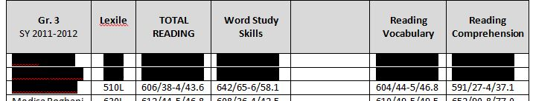
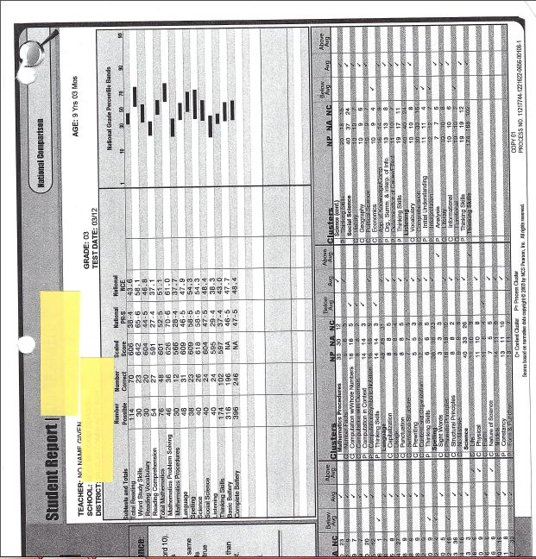

Appendix B
3rd Grade Teacher Interview

Andrea: What can you tell you tell me about Kareem’s learning behavior, performance, and ability last year?
3rd Grade Teacher: **Kareem** is good in Math but needs help in reading and writing. He is a reluctant reader and I told the mom to take him out of Kumon because he doesn’t like it.
Andrea: Anything else to help me with meeting his learning needs?
3rd Grade Teacher: He likes working with his friends but those boys are now in the other schools.

Appendix C
Student work from the Math Group Work on Line, Line Segment, Ray

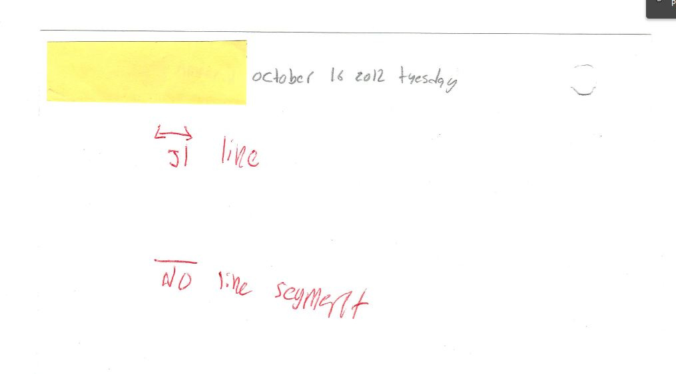

Appendix D
Student Work: Math Graph Showing Mode, Median, Outlier

**Missing Work**

Appendix E
Injury Tally (based on Late Pass for days he came late from the doctor’s office)

Appendix F
Observation Notes

10/3/12—Math Class
Today at small group activity, Kareem got frustrated when he saw that his peers were independently doing their work while he was struggling to understanding the first question. I was there to help him but he started saying he’s “dumb” and the “worst in class”. He had his hand over his head and used his hoodie to cover his face.

10/16/12—Science Class
While doing the guided reading, Kareem volunteered an answer but it was incorrect. When his peers tried to give the correct answer, he got frustrated and started to bang his head on his book.

10/19/12—Math Class
In math class, Kareem got frustrated during the 5-Minute Check for our warm up activity because everyone else were done completing their work and he hadn’t started.

10/31/12—Math Class
Kareem was upset at math class today and was making it hard for the class to focus. I sent him to the Asst. Principal’s office to talk to her and get his mind cleared.

Appendix G
Parent Interview
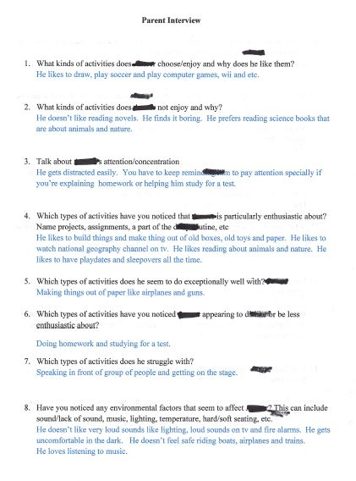

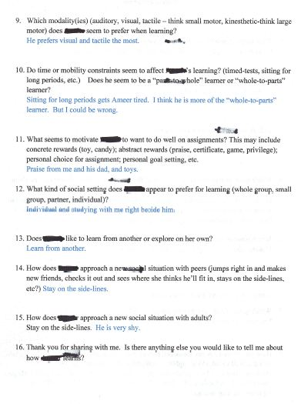

Appendix H
Reading & Writing Elementary Attitude Survey

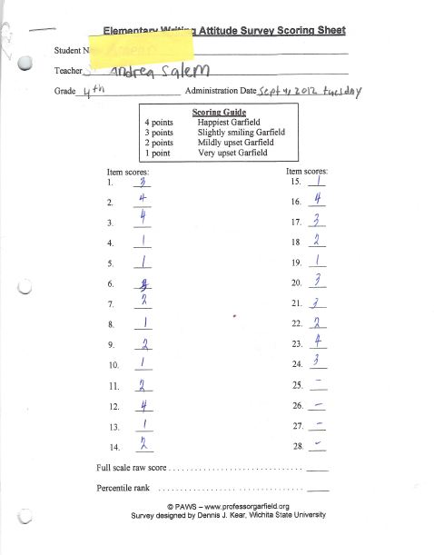

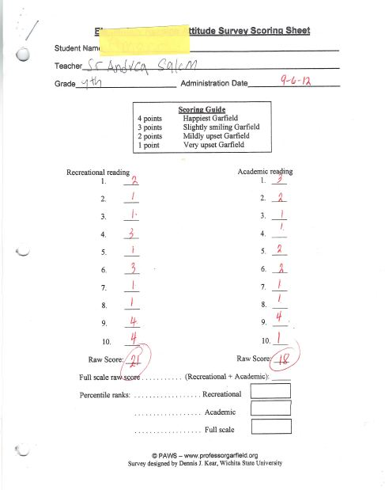

Appendix I
Student Records & Student Work/s
